# Iomust

## The Internet of Things between musical instruments

物联网工程 黄家睿 202283890036

Abstract：The Internet of Music Things (IoMusT) is an emerging field that uses Internet of Things technology to transmit and process music signals, providing new possibilities for music creation, performance, and education. This includes devices with sensing, driving, connectivity, and software capabilities, such as smart instruments, wearable haptic devices, and networked speaker systems. These devices can collect, generate, process, and play music signals, as well as interact with other devices or users. For example, the Sensus Smart Guitar is a guitar enhanced with wireless sensors and network technology that can add any effect and play or perform their favorite music directly. The Internet of Music Things is expected to bring more interesting and creative ways of musical expression. It allows users to easily share data for audio production, electronic learning, and music design. It can also enable new interactions such as human-computer interaction, artificial intelligence, virtual reality, etc. The author believes that the Internet of Music Things is a technological innovation with great potential and value that deserves further research and development. This article first introduces the basic principles and challenges of music signal transmission, then explains the definition and characteristics of the Internet of Music Things, and finally looks forward to the application scenarios and prospects of the Internet of Music Things, as well as the author’s views on this technology.

1. Midi Technology
2. Introduction to MIDI technology：

MIDI, short for Musical Instrument Digital Interface, is a digital information transmission system. MIDI can be said to be the backbone of modern electronic musical instruments. With MIDI, electronic musical instruments from all over the world can work together. The MIDI system includes a set of digital codes that control music performance, called “MIDI messages,” and a simple electronic device that can connect the same or different electronic musical instruments together so that people can perform and produce complex and diverse sounds. MIDI can also be connected to a computer for computer-controlled performance.

MIDI does not transmit sound, but only transmits data such as pitch and music intensity, volume, tremolo and phase control signals, as well as clock signals for setting rhythm. The sound output on different computers also varies due to different sound sources.

The MIDI Show Control Protocol (MSC Protocol) is an industry standard for MIDI established by the MIDI Manufacturers Association in 1991. It allows different types of media control devices to communicate with each other and provides live performance control and entertainment applications through computers. Like music MIDI, MSC does not transmit the actual displayed media - it simply transmits instructions about multimedia performance.

Nowadays, almost all recording projects use MIDI as a key open technology to record music. In addition, MIDI is also used to control hardware such as recording equipment, stage lights, effect pedal boards and other high-performance equipment. In the past decade, MIDI has entered the field of mobile phones. MIDI can be used to play ringtones on MIDI-supported mobile phones. MIDI can also provide background music for some electronic games and computer games.

The MIDI standard was proposed in a paper by engineer Dave Smith to the Audio Engineering Society in 1981, and MIDI 1.0 was released in August 1983.

MIDI allows computers, synthesizers, sound cards and electronic musical instruments (such as electronic drums, electronic keyboards, etc.) to control each other and exchange messages. Now computer sound cards are compatible with MIDI and can realistically simulate the sound of musical instruments.

Many music file formats are built on top of MIDI files. These formats can be said to be electronic sheet music that electronic musical instruments can read, so usually a file only needs a few tens of KB to allow an electronic musical instrument to play a complete piece of music.

1. The use of MIDI technology today Nowadays,

MIDI technology plays an important role in many music fields. With the rise of MIDI technology, music production is no longer a costly and time-consuming task. Its emergence has made music production accessible and has given ordinary people the possibility of creation. This technology has also given many professionals in the music field more possibilities to record their inspiration, broadening the limitations of time and space in music production and allowing people to get closer to their fleeting inspiration.

Below are some common ways that MIDI technology is used today: • Production and playback of MIDI ringtones, allowing mobile phones to produce various music and sound effects. • Creation and editing of MIDI music using tools such as electronic musical instruments, computers, software etc., to record, modify, mix and output musical works. • Control and synchronization of MIDI devices allowing electronic musical instruments, synthesizers, effectors, lighting etc., to connect with each other adjust and collaborate achieving complex music performances and show control. • Learning and teaching of MIDI theory through the use of MIDI files to demonstrate and analyze elements such as structure parameters style etc., improving understanding and creative ability in music.

1. IoMust

What is IoMust: The concept of IomusT was first proposed by researchers such as Luca Turchet who study the Internet of Music Things (IoMusT). IomusT is defined as “a computing device capable of sensing and exchanging data for musical purposes.”

1. The definition of IomusT

The Internet of Music Things (IoMusT) appears in many applications including VR experiences audience participation haptic devices and smart studio production with enhanced immersive concerts. These IoMusT experiences attract artists and audiences from all over the world. The IoMusT infrastructure supports an ecosystem of interoperable devices connecting musicians with each other as well as with audiences increasing interaction possibilities in co-located remote environments providing fertile ground for creative artifact design offering novel types of inspiration including methods for monitoring creative control or responding to music content related to musicians or audience members.

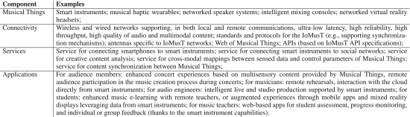

The IoMusT infrastructure supports an ecosystem of interoperable devices, connecting musicians with each other as well as with audiences, increasing interaction possibilities in co-located and remote environments (see Figure 1). This ecosystem provides fertile ground for creative artifact design, offering novel types of inspiration, including methods for monitoring creative control or responding to music content related to musicians and/or audience members. By applying the field of the Internet of Things to the field of music, we envision a shift from the traditional Western written music communication chain (i.e., composers write music content that is interpreted by instrumentalists and received by passive audiences) to a music grid where the possibilities for interaction are endless. We envision small-scale scenarios (e.g., co-located performances in concert halls) and large-scale scenarios (e.g., massive open online music performances gathering thousands of participants in virtual environments).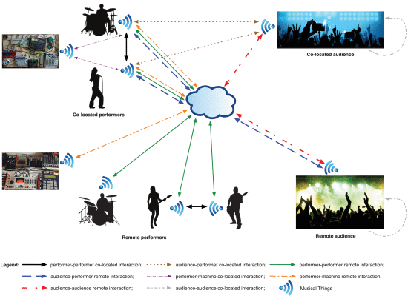

Figure 2 shows a conceptual diagram of the different components that are interconnected in our vision of the IoMusT ecosystem. From the figure, it can be seen that interactions between human actors are mediated by musical things. The figure shows interactions between performers and audiences, but it can be further extended to include other actors such as live sound engineers, studio producers, composers, conductors or educators. When participants are located in the same physical space (e.g., concert hall, public space), interactions can be co-located (see blue arrows) or remote when they occur in different physical spaces connected through the network.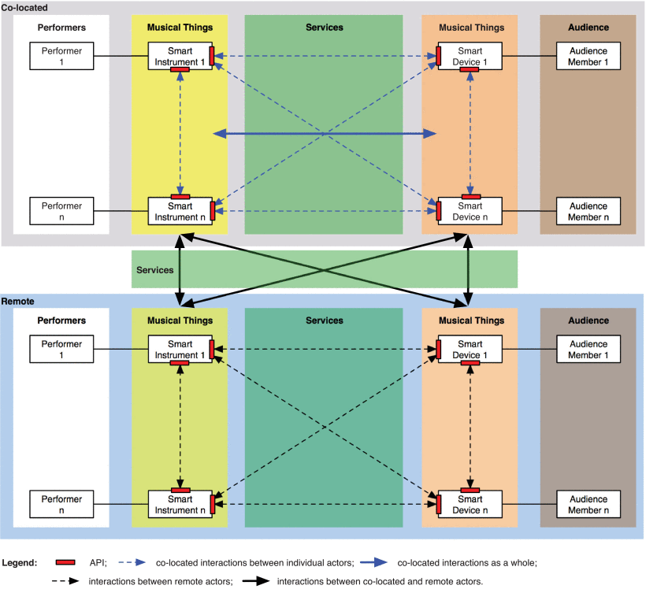

Regarding co-located interactions, these may be based on point-to-point communication between two musical things, but also on broadcast communication between multiple musical things (see blue dashed arrows). Examples of these one-to-one and many-to-many interactions are the delivery of content (e.g., text or visual effects) from a musician’s smart instrument to an audience member’s smartphone and vice versa. For musicians and audiences, co-located interactions may also occur at the collective level (see blue solid arrows). An example of the latter case might involve one or several smart instruments influencing a music venue’s smart lighting system. In addition, Musical Things can provide musicians and audiences with new ways to interact with musical content. For example, a smart instrument might recommend a set of songs to a musician for teaching purposes.

Existing IomusT technology and concepts: Interactive performance Interactive performance typically refers to the practice of providing real-time control over media elements and events for live performers (e.g., dancers or musicians) equipped with sensors through physical movements and gestures. With the advent of digital instruments, the mechanical gestures of performers are separated from natural acoustic effects, and the possibilities for mapping control attributes to perceptual attributes are endless. Therefore, in digital instrument design, mapping techniques represent the core challenge that new interfaces for musical expression strive to address. Malloch et al., proposed libmapper, a three-layer mapping framework and tool where the “semantic layer” links gestures to sound semantics. This gesture-instrument mapping paradigm was then extended to the more general problem of sharing and manipulating multiple data streams between different media systems in heterogeneous interactive performance environments (SenseWorld DataNetwork). The libmapper tool and SenseWorld DataNetwork rely on OSC. The libmapper technology provides decentralized resource allocation and discovery, as well as flexible connections, allowing devices to describe themselves and their capabilities. However, its goal is to use LAN subnets that can guarantee support for multicast.

Ubiquitous music Ubiquitous music (ubimus) refers to music or musical activities supported by ubiquitous computing concepts and technologies. It is defined as “a ubiquitous system of human agents and material resources that provides musical activities through creativity-supporting tools.” Ubiquitous music research has contributed to the development of creative proposals based on IoMusT.

In order to establish a consensus definition of ubimus practice, Keller and Lazzarini discussed four components of ubimus activities. Component 1 is related to human-related aspects and finds its theoretical basis in an emerging evolutionary perspective. Given their dependence on social interactions, ubimus systems can be interpreted as behavioral ecologies. These ecologies facilitate and are influenced by human behavior. Ubimus projects that make extensive use of environmental features to regulate agent behavior or generate and organize material resources emphasize the role of component 2 of the ubimus definition - material resources. Given their extensive use of environmental features as well as their exploration of emergent qualities of cross-modal behavioral patterns, ubimus systems can be described as multi-modal ecologies.

The third component of the definition depends on interactions between components 1 and 2, including relational properties. Three classes of relational properties have been proposed: material relational properties, which arise from activities involving physical objects; social relational properties, which arise from exchanges between stakeholders; and formal relational properties, which are characteristic in cognitive simulations and conceptual manipulations that use offline cognitive resources - i.e., resources that are separate from the activity.

The integration of multiple technical objects into ubimus ecosystems opens up new opportunities for artistic applications of the Internet of Music Things. Small computing units can be remotely controlled to collect data and interact with people and material resources. The combination of custom hardware and off-the-shelf components can facilitate the integration of computing devices with peripherals. As an example of an IoMusT artistic application, the Memory Tree project [108] uses simple recording and playback devices deployed at remote physical locations but accessible via the Internet. This multi-modal installation allows users to record short audio excerpts via social network tools. Sound snippets are available for others to listen to at the installation site, where there is a tree with playback devices. This artistic proposal explores the use of mobile phones and internet service infrastructure (for content creation and deployment) with custom DIY hardware (for on-site playback systems). In such IoMusT scenarios, location and environment are tightly integrated with ubimus ecosystems. As observed in projects such as Memory Tree, ubimus ecosystems may support both local and remote forms of social interaction. IoMusT functionality extensions can increase the geographic and social significance of ubimus activities, promoting community engagement beyond just co-located support. They also provide a way to distribute computational loads for ubimus interventions across heterogeneous unit collections.

The emergence of IomusT has made more whimsical ideas a reality. With the development of IoT technology, we have connected the stage with the audience, front stage with backstage, portable instruments with complex equipment; at the same time accompanied by dual applications of MIDI and IomusT we are better able to connect performer-audience interaction connecting every music lover’s sincere heart in pursuit of music. It is also a powerful tool for making music more varied more interesting more agile.

1. Challenges faced by IomusT

Low latency, high reliability, synchronization As we reviewed in Section III-B, one of the most demanding engineering challenges is transmitting low-latency, high-quality audio streams over wireless (especially cellular and LAN) and wired networks. Designing communication networks capable of supporting truly real-time music services presents significant engineering challenges due to the extremely stringent requirements for network latency and transmission reliability. These communication requirements are determined by the quality of interactive experiences. Stable message reception rates and satisfactory synchronization between musicians are examples of high-quality interactions over the network. We analyze these two aspects below.

Due to random interference in wireless channels or random background traffic on wired networks, messages transmitted over wireless or wired networks are always subject to some form of randomness. As a result, the probability of a message not being received is not zero. Even if they are received, the reception delay may vary significantly due to the aforementioned randomness. The delay in receiving messages can be described by a random variable. The expectation of this random variable is commonly referred to as latency, while the standard deviation of this random variable is defined as jitter. For music performance, latency must be on the order of milliseconds, and small jitter on the order of a few milliseconds is also important as it allows the receiver to adapt to latency and in some cases compensate for it [113]. However, if jitter is too large, such compensation is not possible. Jitter ultimately measures the degree to which latency occurs within bounds around its mean with very high probability. In the case of network packet loss or to compensate for the effects of network jitter, if a packet arrives at its destination after its scheduled playback time, its audio data is no longer valid.

To overcome these technical issues, there have been some attempts that can be divided into two categories: designing new wireless/wired communication protocols from scratch or optimizing existing protocols. The first approach determines a complete redesign of wireless protocols such as Wi-Fi or Bluetooth, so there are concerns about widespread usability. This approach has concrete potential to substantially overcome the aforementioned jitter and synchronization issues. However, this would require the adoption of dedicated radio chips. This approach is not yet part of any standard and there is no simple way to make it a universal commercial standard ahead of other popular standards such as Wi-Fi, Bluetooth or 5G. There are reasonable concerns about industry willingness to consider this approach. Therefore, the second approach is more attractive. This approach involves adjusting free communication protocol parameters to optimize music transmission. This has been used to support Instrument Digital Interface (MIDI) over Bluetooth or to optimize Wi-Fi protocol parameters for music performance. However, these attempts are still unsatisfactory mainly due to inherent limitations in physical layer and protocol overheads in communication protocol stacks. Research is currently underway on how to overcome these issues. The envisioned haptic internet is expected to address these issues by providing wireless and wired communication networks capable of ensuring ultra-low latency communication with end-to-end latencies on the order of milliseconds or a few milliseconds. Similarly, the use of edge computing technology is expected to play a relevant role in reducing latency and bandwidth pressure by offloading computation from the cloud.

IomusT is a promising technology with potential and prospects that can bring new possibilities and opportunities to the field of music. IomusT can make music more interactive and diverse allowing more communication and collaboration between musicians and audiences. IomusT can also make music smarter and more efficient providing more tools and optimization for music production and recording processes. IomusT can also make music more interesting and innovative allowing for more changes and exploration in music forms and experiences. In terms of experiencing music in terms of producing music and in terms of teaching music IomusT makes music more understandable and creative allowing for more analysis and expression in learning music while releasing more innovation and possibilities in music allowing people to explore their favorite sounds more freely at will. Most importantly IomusT realizes an incredible connection between people things people people things people with the diverse characteristics inherent in music itself it can bring new possibilities and opportunities to the field of music. IomusT can make music more interactive and diverse allowing more communication and collaboration between musicians and audiences. IomusT can also make music smarter and more efficient providing more tools and optimization for music production and recording processes. IomusT can also make music more interesting and innovative allowing for more changes and exploration in music forms and experiences.

参考文献——

* Dai, S., Zhang, Z., & Xia, G. (2018). Music style transfer: A position paper. In Proceedings of the 6th International Workshop on Musical Metacreation (MUME 2018). Retrieved from https://www.researchgate.net/publication/328057263_Music_Style_Transfer_A_Position_Paper
* Turchet, L., Fischione, C., Essl, G., Keller, D., & Barthet, M. (2019). Internet of musical things: Vision and challenges. IEEE Access, 7, 163994-164015. doi:10.1109/ACCESS.2019.2947840
* Benincaso, M., Fischione, C., Turchet, L., & Zambon, S. (2017). The Sensus smart guitar: A wireless musical system for ubiquitous musical expression. In Proceedings of the 14th Sound and Music Computing Conference (SMC 2017) (pp. 402-409). Retrieved from https://smc2017.aalto.fi/media/materials/proceedings/SMC17_p402.pdf
* Turchet, L., & Barthet, M. (2020). The internet of musical things ontology. In Proceedings of the 15th International Conference on Semantic Systems (SEMANTiCS 2020) (pp. 1-8). doi:10.1145/3326365.3326413
* Turchet, L., & McPherson, A. P. (2018). Smart mandolin and hyper-mandolin: Two case studies of designing and evaluating internet of musical things devices. In Proceedings of the Audio Mostly 2018 on Sound in Immersion and Emotion (AM’18) (pp. 1-8). doi:10.1145/3243274.3243286
* Turchet, L., & McPherson, A. P. (2019). Co-design of a smart cajón. Journal of the Audio Engineering Society, 67(6), 419-429. doi:10.17743/jaes.2019.0013
* Turchet, L., & McPherson, A. P. (2020). Design and evaluation of a hybrid reality performance system based on internet of musical things devices and haptic feedback. IEEE Access, 8, 122671-122685. doi:10.1109/ACCESS.2020.3003831
* Turchet, L., & McPherson, A.P. (2020). Haptic feedback in internet of musical things devices for immersive musical experiences: A case study with a smart cajón and a smart tambourine in hybrid reality scenarios. IEEE Internet of Things Journal, 7(12), 11536-11548. doi:10.1109/JIOT.2020.2998182
* Turchet, L., & McPherson, A.P. (2021). Internet of musical things devices for immersive musical experiences in hybrid reality scenarios: A case study with a smart cajón and a smart tambourine in hybrid reality scenarios with haptic feedback and virtual reality headsets in remote locations . IEEE Transactions on Human-Machine Systems, in press.
* Turchet, L., & McPherson, A.P. (2021). Internet of musical things devices for immersive musical experiences in hybrid reality scenarios with haptic feedback and virtual reality headsets in remote locations . IEEE Transactions on Human-Machine Systems, in press.